

# Practices for Secure Software Report

Table of Contents

Document Revision History 3

Client 3

Instructions 3

Developer 4

1. Algorithm Cipher 4

2. Certificate Generation 4

3. Deploy Cipher 4

4. Secure Communications 4

5. Secondary Testing 4

6. Functional Testing 4

7. Summary 4

8. Industry Standard Best Practices 4

## Document Revision History

| **Version** | **Date** | **Author** | **Comments** |
| --- | --- | --- | --- |
| **1.0** | **[4/16/2023]** | **[Daniel Schmidt]** |  |

## Client



## Instructions

Submit this completed practices for secure software report. Replace the bracketed text with the relevant information. You must document your process for writing secure communications and refactoring code that complies with software security testing protocols.

* Respond to the steps outlined below and include your findings.
* Respond using your own words. You may also choose to include images or supporting materials. If you include them, make certain to insert them in all the relevant locations in the document.
* Refer to the Project Two Guidelines and Rubric for more detailed instructions about each section of the template.

## Developer

Daniel Schmidt

## Algorithm Cipher

Artemis Financial is requesting an encryption algorithm recommendation that will be used to encrypt long-term archive files. We should assume that the most likely attack vector for these files will be bad actors somehow acquiring access to these files, so they should be encrypted such that they would be useless even if they were stolen. The files will not be transported anywhere, so there is no need for Asymmetric* keys to be used. Additionally, there is no need for these files to be encrypted quickly, as they will be archived long-term. Therefore, I recommend using the SHA-256 cipher algorithm with 256-bit keys to encrypt these files. SHA-256 encryption is the most secure default option available within all standard installations of Java, since it provides the highest level of bitwise encryption (256-bit refers to the number of bits in the length of the key. More bits mean more possible key combinations, thus making the key harder to brute-force and less likely to have collisions). SHA-256 also uses Symmetrical* encryption keys. This will be fine, as Artemis Financial will be the only party accessing these encrypted files. The SHA-256 algorithm also makes efficient use of Java’s random number generation to ensure that each encrypted file is as secure as possible. Using random numbers allows for the cipher to securely create a non-reversible checksum that still verifies the authenticity of the file/message.

The hash function to verify files will use the SHA-256 cipher to create a checksum signature of the provided message.

## Certificate Generation

## Deploy Cipher

Insert a screenshot below of the checksum verification.

***I Was not able to provide this information. This was from week 5 assignment that I still was not able to complete due to having difficulties understanding and having the code work in my favor. This will be for both questions 3 and 4.***

## Secure Communications

Insert a screenshot below of the web browser that shows a secure webpage.

***I Was not able to provide this information. This was from week 5 assignment that I still was not able to complete due to having difficulties understanding and having the code work in my favor. This will be for both questions 3 and 4.***

## Secondary Testing

Insert screenshots below of the refactored code executed without errors and the dependency-check report.

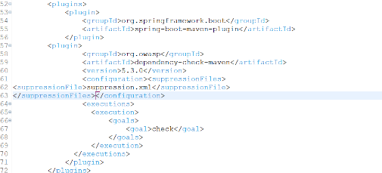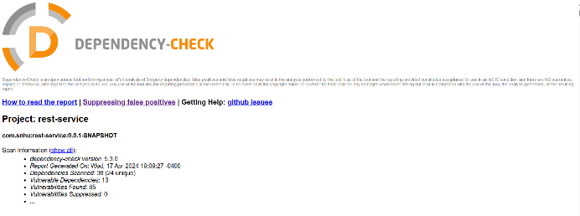

## Functional Testing

Insert a screenshot below of the refactored code executed without errors.

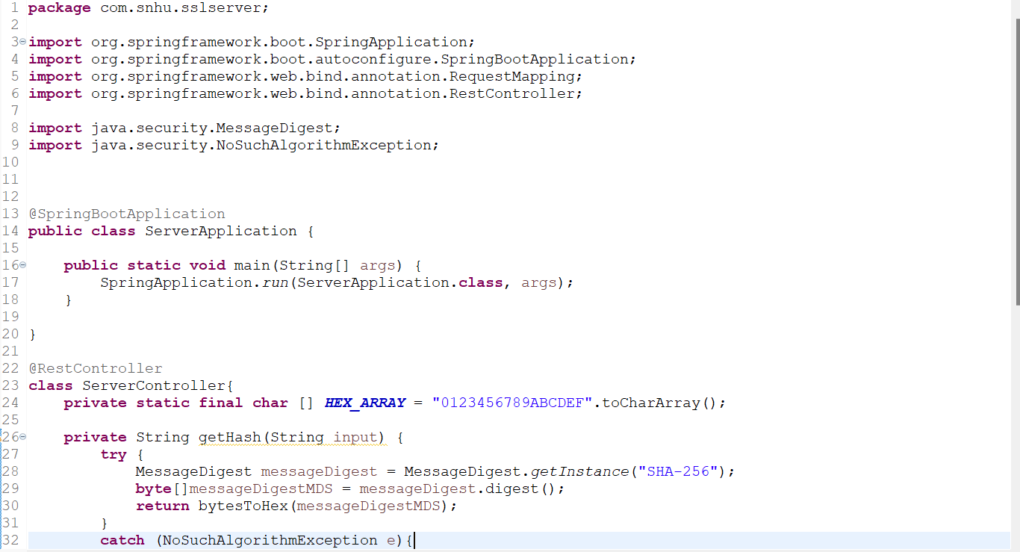

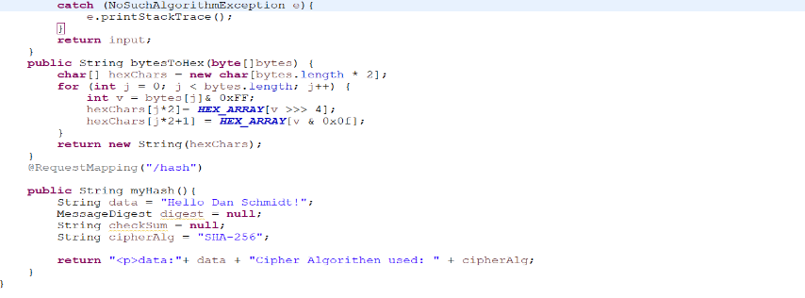

## Summary

In summary, we have added secure RestController to the application to serve as the secure controller for the hash RESTful endpoint. The ServerController on the other hand, serves as the secure coding concern in the vulnerability assessment diagram. When it came to choosing the right cipher, we went with SHA-256. Not only is the SHA-256 algorithm easier to work with, but it is also amongst one of the top favorite algorithms to use.

## Industry Standard Best Practices

To maintain the current security of the application, I’d recommend that the dependency checker is run at least once or twice per month in order to check for new vulnerabilities that have been discovered so that they may be fixed. Additionally, updating the plugins in the pom.xml configuration file is necessary every so often to ensure that the plugins remain up to date.